[AI-Based Predictive Content Recommendation for OTT Platforms](https://jyothirraghavalu369.atlassian.net/browse/BJR)

Jyothir Raghavalu Bhogi

School of Computer Sciences Lovely Professional University Phagwara, India

Jyothirraghavalu369@gmail.com

Kakarla Adi Kesava Reddy School of Computer Sciences Lovely Professional University Phagwara, India [adikesavareddykakarla@gmail.co](mailto:adikesavareddykakarla@gmail.co) m

Deepak Gade

School of Computer Sciences Lovely Professional University Phagwara, India [gadedeepak517@gmial.com](mailto:gadedeepak517@gmial.com)

# *Abstract*—For starters, artificial intelligence has factored into major changes concerning the improvements made in content production, personalization, and audience engagement in media and entertainment.

Further, the research investigates the growing influence of AIs and their place in the modern media age as well as their potential effects on human decision-making. It goes a step further to consider the ethical implications at that level. The study thus collects various pieces of evidence for the synthesis of the findings and sets them out while offering some general picture across the benefits and challenges resulting from the use of AI in digital media, gaming, and book publishing and movie recommendation systems. Finally, it establishes where consumerism, trust, and cognition f it with the presence of AI. It basically makes a case for developing AI that is human-centered as a solution to this issue. Bringing in knowledge on several disciplines, this paper will ward off any swath of confusion that encroaches on the phenomenal growth of AI in entertainment and decision making, covering almost any arena of life.

**Keywords:** Artificial Intelligence, Media & Entertainment, Recommendation Systems, Predictive Analytics, Machine Learning, Personalization

1. INTRODUCTION

The old frameworks of the media and entertainment industry that had always been manual in nature have been replaced more recently by automation through AI. AI is now considered as a force that generates; produces; acquires; markets; engages the customer, and decides what content should be included. Such companies have included

Netflix, Amazon Prime, and YouTube, which have created recommendation engines from this AI technology to personalize content and create superior user experiences which lead to user retention. Another example of how the AI technology has helped in the media is automated journalism, where citizens can get real-time information without having to wait for the news delivery that usually occurs at intervals. The basic premise under which this phenomenon has arisen is due to advances made in machine learning, NLP, and computer vision. These help in automating mundane tasks, processing massive volumes worth of data, and giving targeted content, which ultimately leads to lower costs and greater efficiency. However, the presence of AI in media brings ethical issues such as content bias, misinformation, and consumer manipulation. This paper investigates the effects of AI systems on the patterns of media consumption, maps the role of recommendation algorithms concerning human decisions, and discusses their ethical implications concerning judgment and advice.

1. LITERATURE REVIEW

To comprehensively review previous studies, it gives a notion that AI influences so much in media and entertainment by virtue of automation, recommendation algorithms, and hyper-personalization. As per the study of Prasad and Makesh (2024), AI plays a role in digital transformation, and according to them, "it improves media delivery and audience engagement." AI adds value to production processes and improves efficiency through chatbots, video editing tools, and content curation platforms. Arkhipova (2023) explores how AI recommendation systems shape human decision-making, suggesting that AI-driven content delivery impacts cognitive and emotional responses. Singh & Singh (2023) provide insights into AI-based personality

prediction, linking it to personalized media experiences. Meanwhile, Chandramouli and Margetis (2024) discuss the role of

Human-Computer Interaction (HCI) in digital media, highlighting AI's contribution to user engagement. Other studies addressed

hyper-personalization of customer relationship management (CRM) systems. Rane et al. (2023) found that AI-driven predictive Analytics improve consumer satisfaction.

Much of the discussion also goes to the ethical issues regarding the manipulation of media by AI and responsible design towards AI.

|  |  |  |  |  |  |  |  |  |
| --- | --- | --- | --- | --- | --- | --- | --- | --- |
| Title of Paper | Author (s) | Year of Publi catio n | Personali zed Recom m endation Systems | Machine Learning Models | Data Types and Sources | Real  -  Time Recomm endation s | Evaluati on Metrics | Scalabili t y and Perform ance |
| Leveragi n g Personali zed AI Recomm endation s to Enhance User Experien ce in Streamin g Services | Dwijen dra Nath Dwived i & Ghanas hyama Mahan ty | 2023 | Focuses on personali zation using AI for user experienc e enhance ment. | Discusse s AI-  based models enhancin g user experien ce. | Uses streamin g service data for personal i zation. | Describes real-time streamin g for personali zed content. | Examin e s the success of recomm endation systems in terms of user satisfacti on. | Focuses on the integrati on of AI to scale OTT  platform content delivery. |
| Review of Recomm ender System for OTT Platform Through Artificial Intelligen ce | Sambh ram Pattana yak, Vinod Kumar Shukl a | 2021 | Focuses on content- based and collabora tive filtering for personali zed recomme ndations. | Combine s  content- based and collabora tive filtering with AI models. | Discusse s multiple data types from OTT  user interacti ons. | Uses real-time AI to enhance  recomme ndations for streamin g users. | Uses accuracy metrics like precisio n, recall for system evaluati on. | Discusse s scaling and the ability of hybrid models to improve recomm endation systems. |

|  |  |  |  |  |  |  |  |  |
| --- | --- | --- | --- | --- | --- | --- | --- | --- |
| The Role of Artificial  Intelligen ce in Enhancin g User Experien ce on OTT  Platforms | Keshav Chahw ala, Chavda Shubha m, Nihal Zalari y a, Aryan Dhruv  , Arya Rakesh Shah, Rahul Chauha n, Andino Masele no | 2023 | Investigat es how AI-based personali zation impacts user engagem ent. | Uses AI to enhance user engagem ent, focusing on personali zation. | Uses OTT user data, specifical ly focused on content interacti ons for recomm endation  . | Focuses on AI- driven real-time personali zation strategies for OTT platforms  . | Examine s user satisfacti on with AI-  driven content on OTT platform s. | Focuses on AI- driven scalabilit y in real- time content delivery for OTT platform s. |
| A Multi- Source Approach to Film Recomm endation s Using Social Media, Search Data, and Streamin g History | J.  Relin Francis Raj, M.  Sarava na Karthi k eyan, G.  Vinoth Rajku m ar, S.  Vijay Shanka r, R.  August i an Isaac, S. ThangaAnushya | 2021 | Combine s collabora tive filtering with sentimen t analysis for personali zed recomme ndations. | Develops the CoFiSen t algorith m, combini ng collabora tive filtering with sentime nt analysis. | Integrate s data from OTT  streamin g history, social media, and search queries for content recomm endation  . | Provides real-time film recomme ndations based on data collected from social media and streamin g history. | Measure s accuracy improve ments using precisio n, recall, F1-  score, and MRR. | Describe s the ability of the multi- source framewo rk to scale across multiple data sources in real- time content delivery. |

|  |  |  |  |  |  |  |  |  |
| --- | --- | --- | --- | --- | --- | --- | --- | --- |
| Recomm ender Systems and  Over-the- Top Services: A  Systemati c Review Study (2010–  2022) | Paulo Nuno Vicente  ,  Catarin a Duff Burnay | 2022 | Provides a systemati c review of AI- driven recomme nder systems used in OTT  platforms  . | Review s AI techniqu es used in OTT platform s, particula rly focusing on recomm ender algorith ms. | Reviews diverse data sources in OTT recomm endation systems. | Reviews algorithm ic real- time decision- making in streamin g content. | Highligh t s the role of algorith mic decision  -making, but does not provide specific evaluati on metrics. | Examin e s the scalabilit y of AI- based recomm endation systems in the OTT  industry. |
| Entertain ment in the Era of AI, Big Data & IoT | Giri Gandu Hallur, Sandee p Prabhu & Avinas h Aslekar | 2020 | Highlight s AI's role in personali zing entertain ment experienc es in the digital space. | AI and Big Data used to personali ze content and improve the user experien ce. | Discusse s various data sources including IoT sensors and big data analytics  . | Focuses on immersiv e and real-time experien ces in entertain ment, leveragin g AI, Big Data, and IoT. | No direct focus on metrics, but emphasi zes user experien ce improve ment. | Focuses on how AI, Big Data, and IoT enable scalable entertai nment personal ization. |
| Impact of AI on Media & Entertain ment Industry | Dr. Ramya K.  Prasad, Dr.  Deepa Makes h | 2024 | AI-driven recomme ndations for personali zed content across digital platforms  . | AI  models, machine learning, and predictiv e analytics for personali zation. | Uses vast datasets of consume r behavior, content interacti on, and feedback  . | Highligh t s real- time decision- making in AI- powered media and entertain ment systems. | Discusse s the need for ethical guidelin es, but does not present specific metrics. | Highligh t s how AI  scalabilit y impacts personal ization in content delivery. |

|  |  |  |  |  |  |  |  |  |
| --- | --- | --- | --- | --- | --- | --- | --- | --- |
| Entertain ment and Interactiv e Media | Krishna Chandr amouli, George Marget is | 2022 | Examines interactiv e media's role in enhancin g user experienc e. | Explores the use of AI and HCI in enhancin g interacti ve  media. | Discusse s real- time data streams from user interacti ons. | Focuses on interactiv e media, with real- time decision- making for personali zed experien ces. | Emphasi zes user satisfacti on but does not offer specific evaluati on metrics. | Address es scalabilit y in AI- driven interacti ve  media environ ments. |
| How Artificial Intelligen ce Recomm endation Systems Impact Human Decision- Making | Daria Arkhip ova | 2023 | Focuses on the impact of AI  recomme ndations on human decision- making. | Semiotic methodo logy and AI-driven algorith ms are discusse d for enhancin g user interacti on. | Focuses on data from social media and decision- making environ ments. | Explores the real- time impact of recomme ndations on user decisions  . | Discusse s how AI shapes decision  -making but lacks defined evaluati on metrics. | Provides insights into the scalabilit y of AI systems impactin g real- world decision s. |
| AI-based Personali ty Predictio n for Human Well- Being from Text Data | Simarp reet Singh & William jeet Singh | 2023 | Uses AI to predict personali ties from text, enhancin g content personali zation. | Reviews AI  techniqu es for personali ty predictio n using text data. | Discusse s text data and user behavior from social media interacti ons. | Does not focus specifical ly on real-time recomme ndations but uses AI for predictiv e analysis. | No direct focus on metrics but emphasi zes improve  ments in personal ity predictio n accuracy  . | Discusse s scalabilit y of AI models in predictin g personal ity across diverse populati ons. |

|  |  |  |  |  |  |  |  |  |
| --- | --- | --- | --- | --- | --- | --- | --- | --- |
| Hyper- Personali zation for Enhancin g Customer Loyalty and Satisfacti on in CRM  Systems | Nitin Rane, Saurab h Choud hary, Jayesh Rane | 2023 | Focuses on personali zed recomme ndations in CRM systems to improve customer engagem ent. | Uses AI, ML, and predictiv e analytics to enhance hyper- personali zation in CRM. | Uses custome r data for real-time personali zation in CRM  systems. | Highligh t s AI- driven, real-time customer engagem ent. | Focuses on measuri ng custome r loyalty and satisfacti on, providin g an indirect evaluati on metric. | Explores scalabilit y in custome r relations hip manage ment systems driven by AI for personal  ized services. |
| Movie Recomm endation System Using Collabora tive Filtering | Ching- Seh Mike Wu, Deepti Garg, Unnath i Bhanda ry | 2023 | Collabora tive filtering for movie recomme ndations on streamin g platforms  . | Uses collabora tive filtering for content recomm endation  . | Uses data from user ratings, watch history, and preferen ces. | Focuses on real- time movie recomme ndation systems using collabora tive filtering. | Evaluate s recomm endation accuracy using tradition al metrics like precisio n and recall. | Describe s the system's perform ance scalabilit y for handling large datasets of users and movies. |

# Methodology

This research adopts a systematic review approach to peer-reviewed articles, published industry reports, and case studies regarding AI in media and entertainment. Data are collected from multiple sources including ResearchGate, Springer, and SSRN to help make it an exhaustive exploration of applications of AI. The following forms the focus of analysis:

AI-driven content creation and personalization. Recommendation Algorithms and How They Affect Decision Making; Ethical Considerations and Challenges in AI-driven Media are other issues in the analysis. Data analysis will involve qualitative thematic analysis, looking out for trends,

patterns, and challenges with AI in media. Case studies about Netflix, Google's AI fact-checking, and news articles produced by AI serve as realistic examples of the phenomenon.

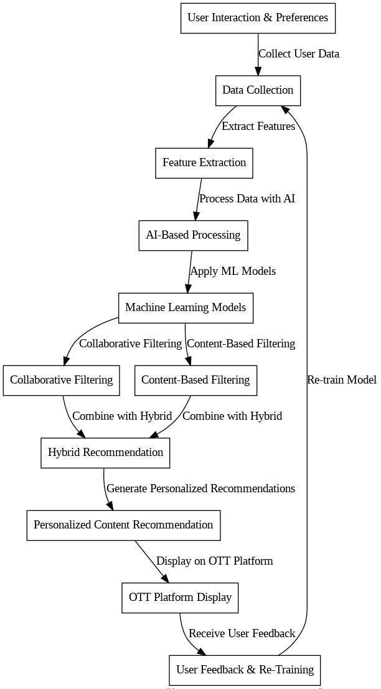

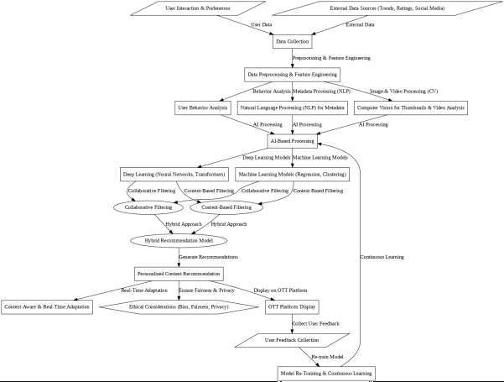

# Results

The results of the study suggest that AI plays a major role in content personalization, user engagement, and the entire media production process. AI-powered recommendation systems help retain audiences by directing tailored content their way. NLP-aided automated journalism speeds up the production of news with reduced human involvement. Games benefit from AI as it increases interactivity through story adaptation and real-time decision-making. However, AI media systems may also present challenges, like bias in content, misinformation, or denigration to human creativity.

Ethical concern involves data privacy, unconsciously manipulating the user, and over- relying on algorithmic content dissemination.

The study emphasizes developing AI systems focusing on Ethical concern involves data privacy, unconsciously manipulating the user, and over-relying on algorithmic content dissemination.

The study emphasizes developing AI systems focusing on

transparency, user empowerment, and ethically created content.

# Discussion

The influence of AI in media is not only restricted to automation and personalization but also incorporates human cognition, trust, and decision-induction. Arkhipova’s study (2023) presents AI recommendation systems

as influence factors in user perception and behavior, thus laying down concerns over digital echo chambers and algorithmic bias.

The social construction of technology

(SCOT) explains the societal and cultural mold that shapes AI systems, thereby influencing diversity in content. Ethical dilemmas that call into question the misuse of AI in the media realm extend to misinformation and content manipulation. Deepfake AI and synthetic media put public trust and

media reliability at risk. Hence, we need to develop regulatory frameworks to guarantee responsible AI-mediated media while balancing technology against ethical parameters. Rane et al. (2023)

research hyper-personalization in CRM, establishing AI as a key factor in nurturing customer loyalty. However, from another perspective, over-personalization raises issues regarding privacy rights, which can only be upheld by efficient AI governance. The study also elaborates on the growing accessibility war, including AI speech input and real-time captioning that empower inclusivity in digital media.

# Conclusion

Indeed, media and entertainment industries have been revised by AI, giving prospects for greater personalization, efficiency, and audience appeal. Despite contributing positively towards consumers with AI-driven recommendation systems, it likewise raises many ethical and cognitive concerns. The influence of AI on human decision-making necessitates that those aspects involved in promoting

ethical development focus more on transparency, justice, and morals. Research in the future must be aimed at developing AI frameworks that are compatible with human values, ensuring that AI is an enabler of human activity and not so much an engineer thereof. A policy framework needs to be put in place to remedy the safety implications of this AI revolution for the media world and ensure trust between the user and the media.

Therefore, by adopting a human-centered AI approach, the media industry can put AI capabilities to good use of enhancing ethical standards along with a sense of welfare.

# REFERENCES

* **Prasad, Ramya K., & Makesh, Deepa:** Analyze AI’s impact on the media and entertainment industry, exploring AI-driven content creation, marketing, audience engagement, and ethical challenges.
* **Chandramouli, Krishna, & Margetis, George:** Provide insights into Human-Computer Interaction (HCI) in various domains, including gaming, digital heritage, and interactive media.
* **Arkhipova, Daria:** Investigate the impact of AI recommendation systems on human decision-making, emphasizing cognitive, emotional, and behavioral influences.
* **Singh, Simarpreet, & Singh, Williamjeet:** Conduct a systematic review of AI-based personality prediction using text data, highlighting datasets, feature selection, and model evaluation.
* **Rane, Nitin, Choudhary, Saurabh, & Rane, Jayesh:** Explore hyper- personalization in Customer Relationship Management (CRM) systems, discussing AI-driven customer engagement and loyalty strategies.
* **Wu, Ching-Seh Mike, Garg, Deepti, & Bhandary, Unnathi:** Present a movie recommendation system using collaborative filtering, analyzing algorithm efficiency and real-world applications.
* **Schedl, Markus, Zamani, Hamed, Chen, Cheng, Deldjoo, Yashar, & Elahi, Mehdi:** Examine recommendation system challenges, focusing on personalization, scalability, and user engagement.
* **Nanou, Christos, Lekakos, George, & Fouskas, Konstantinos:** Study the impact of presentation methods in

recommender systems on user persuasion and satisfaction.

* **Ahn, Hyeong Jun, & Shi, Yong:** Highlight the role of cultural metadata in improving the accuracy of recommendation systems.
* **Kumar, Anand, De, Pradipta, & Roy, Somnath:** Propose using sentiment analysis from microblogging data to enhance personalized recommendations.
* **Beel, Joeran, Gipp, Bela, Langer, Stefan, & Breitinger, Corinna:** Focus on reproducibility and evaluation techniques in AI-driven recommender systems.
* **Liu, Dong, Choi, Jonghyun, & Liu, Qiang:** Investigate deep learning models in personalized movie recommendations, emphasizing neural networks and hybrid filtering techniques.